**A-Level Computer Science**

**Bridging the Gap - Computational Thinking**

**\_\_\_\_\_\_\_\_\_\_\_\_\_\_\_\_\_\_\_\_\_\_\_\_\_\_\_\_\_\_\_\_\_\_\_\_\_\_\_\_\_\_\_\_\_\_\_\_\_\_\_\_**

**Q1 - Balls**

Numbered balls roll down ramps. The order of the balls changes as they fall into holes. When a ball comes to a hole, if there is enough space, the ball falls in, otherwise, the ball rolls past the hole. A pin at the bottom of each hole can be pulled which ejects the balls.

Here is an example:

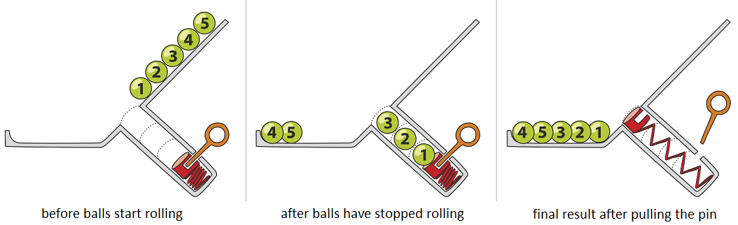

Ten balls roll down the ramp shown below.  
Three holes A, B and C have space for 3, 2 and 1 balls as shown.  
The pins are pulled in the order A, B, C but, each time, only after all the balls have stopped rolling.

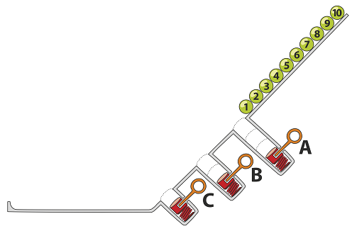

**Question:**What is the final result?

|  |
| --- |
|  |

**Q2 - Beavers on the run**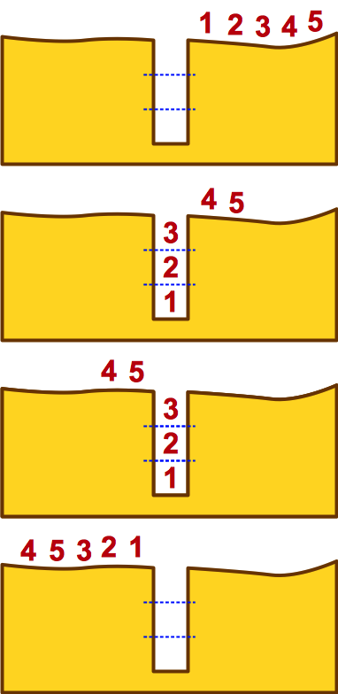

A colony of beavers is travelling through a dark forest.  The path is narrow, so they travel in a row without passing.

Sometimes there is a hole in the path. A hole is passed in the following manner:

* First as many beavers jump into the hole as fit in.
* The entire colony will then pass across the hole.
* The beavers that jumped in will then climb out.

The images on the right show how five beavers pass a small hole that fits three beavers.

**Question**

A colony of 7 beavers passed through the forest. They pass over 3 holes. The first hole fits 4 beavers, the second fits 2, and in the last hole fit 3 beavers.

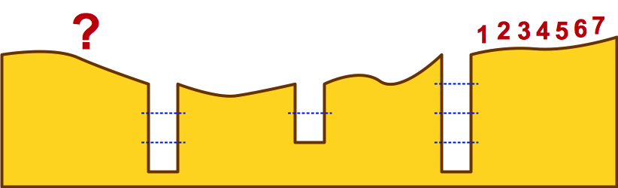

What order do the beavers find themselves after they have passed the third hole?

## Q3 - B-enigma

A message is to be sent secretly. A mechanism called the B-Enigma machine is to be used to encrypt the message.

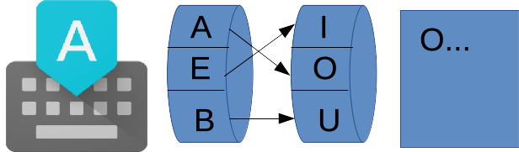

The B-Enigma works as shown above. Each time a letter is typed (e.g. “A”), the left rotor will find a letter on the right rotor according to the arrows (e.g. “O” for “A” in the first step). After typing a letter, the left rotor will move up one position.

This is shown in a different way in the diagram below. After rotating up one position the left rotor will then be in position (2). However, note that the rotor on the right never moves. The links between the two rotors (shown by the straight arrows) also remain the same.

In the diagram below, all the letters available are shown on both rotors.

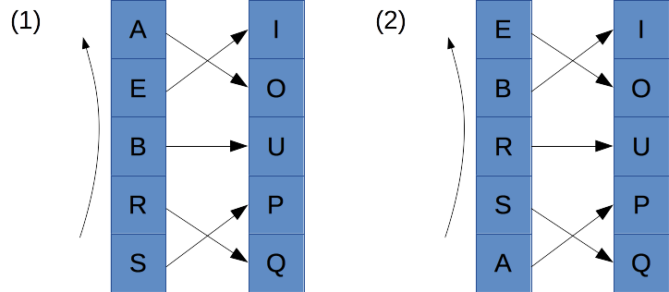

**Question:**The message “BEBRAS” is going to be sent. What will the encrypted message be if we start from position (1)?

**Q4 - Beaver Logs**

The beaver community is designing a new dam on the river. They want to use the least number of logs. They are clever, so they want to take advantage of the small islands in the river. The picture shows the river, the islands, and the number of logs needed to build each dam segment.

**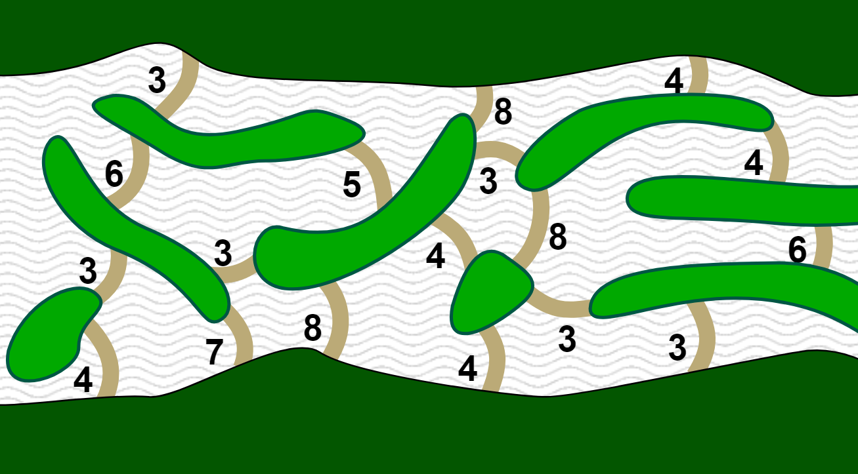**

**Question:**

What is the least number of logs needed for the new dam?

## Q5 - Beaver Lunch

The cafeteria gives instructions on how to choose a Beaver lunch.

This is shown as a diagram:

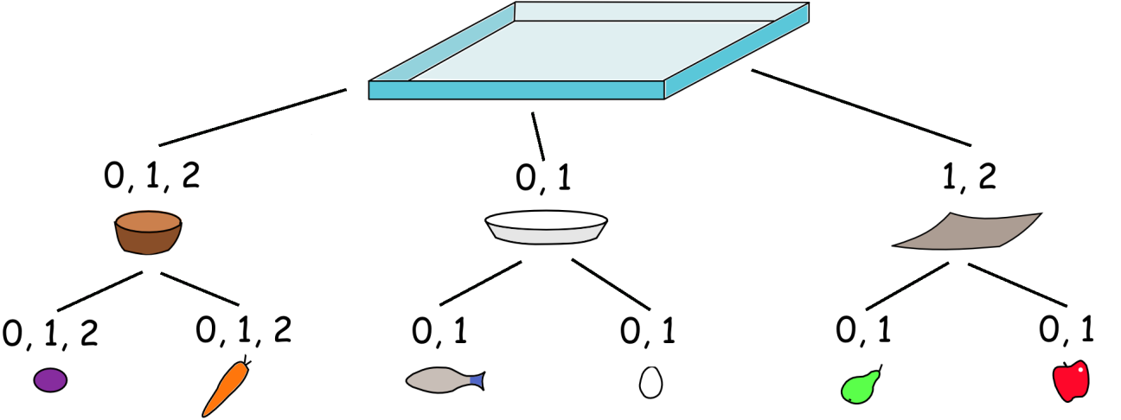

Below the tray you see different types of food containers.

The numbers indicate how many containers of this type can be added to a tray.

Each container can only have food items put in it that are shown below it. The numbers indicate how many food items of this type can be added to the containers.

**Question:**Determine which of the following are Beaver Lunches?

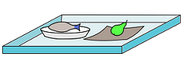

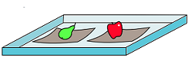

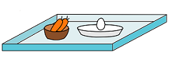

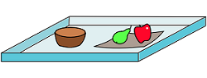

## Q6 - Book sharing club

This diagram shows the relationship between 7 students in a book-sharing club. Their names and ages are also shown.

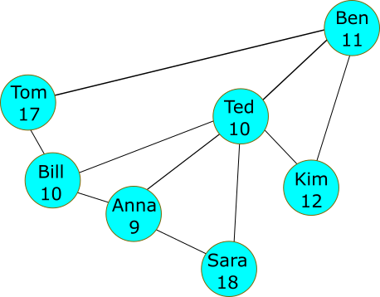

The club has some regulations for members:

*When you receive a book you read it (if you haven't already done so) and then pass it to the youngest friend who has not read it yet. If, however, all your friends have read the book then you should pass it to the friend who first gave it to you.*

Now Ben has read a new book and wants to share it with his friends.

**Question:**In which order will the students read the book?

**Q7 - Broken machines**

The machines can use two different components, called '*max*' and '*min*'.

|  |  |
| --- | --- |
| 2014-CA-01-EN-max | 2014-CA-01-EN-min |
| '*max*' takes two numbers and outputs the largest. | '*min*' takes two values and outputs the smallest. |

3 Machines are designed to give the 2nd largest number from a set of inputs:

|  |  |  |
| --- | --- | --- |
| Machine 1 | Machine 2 | Machine 3 |
| 2014-CA-01-EN-a | 2014-CA-01-EN-b | 2014-CA-01-EN-c |

For example, if the numbers 4, 3, 2, 1 are put into Machine 1, the output is 3, which is indeed the 2nd largest value:

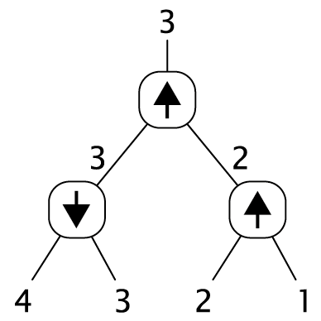

**Question:**For each machine find an input for which it **does not** give the 2nd largest value as intended.

## Q8 - Cipher Wheel

A message has been encoded by using a wheel.

The wheel works such that only the inner wheel (with small letters) can be rotated. The outer wheel is for the actual message.

As you can see in the first image, when the key is 0 ‘A’ is encoded as ‘a'.  
The second image shows that when the key is 17 (because the inner wheel has been rotated by 17 positions counter-clockwise) 'A' is encoded as 'r'.

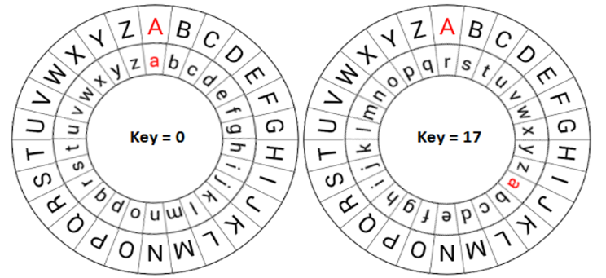

With the key equal to 17, we can encode the message WHO ARE YOU as *nyf riv pfl*

The message **j cp mwuu ujx** is received. We know that this was encrypted in a clever way:  
For the first letter the key was 1, for the second letter the key was 2, the key for the third letter was 3, etc.

**Question:**Decipher the encrypted message

**Q9 - Drawing Stars**

Stella the beaver loves to draw stars. She has devised a system for labeling her stars according to their shape. She uses two numbers:

* A number of dots for the star.
* A number indicating if a line from a dot is drawn to the nearest dot (the number is 1), the second closest dot (the number is 2), etc.

Here are four examples of Stella's labeling system:

|  |  |  |  |
| --- | --- | --- | --- |
| 2015-SE-01-EN-52 | 2015-SE-01-EN-62 | 2015-SE-01-EN-71 | 2015-SE-01-EN-83 |
| 5:2 | 6:2 | 7:1 | 8:3 |

**Question:**How would Stella label the following star?

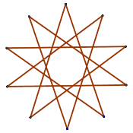

**Q10 - Footprints**

Footprint-trees are made by stepping in the sand in a special way:

|  |  |
| --- | --- |
| The instructions for a **1-tree:** | |
| Step forward 1 step to make one footprint, go back in your own prints. | 2014-DE-02-DE_Footprints_Picture_1-tree 1-tree |
| When you know how to make a 1-tree, you can learn how to make a **2-tree**: | |
| Step forward 2 steps to make two footprints.  Turn left and make a 1-tree.  Turn right and make a 1-tree.  Go back in your own prints. | 2014-DE-02-DE_Footprints_Picture_2-tree 2-tree |
| It is easy to explain how to create a **3-tree** because a 3-tree consists of 2-trees. | |
| Step forward 3 steps to make three footprints.  Turn left and make a 2-tree.  Turn right and make a 2-tree.  Go back in your own prints. | 2014-DE-02-DE_Footprints_Picture_3-tree 3-tree |
| In a similar way you can create a **4-tree**. | |

**Question:**Draw a 4-tree.

## Q11 - Funtime School

The teachers at *Funtime School* like to include games in their lessons.

At the end of one day, one teacher invites his students to play a game. The winner gets to leave school before the others are dismissed.

Rules of the game:  
The school has one corridor with five doors in a row. The students form a queue and take turns to walk down the corridor.

* When they get to an open door, they must close it and move to the next door.
* When they get to a closed door, they must open it, go into the classroom, leave the door open and wait there until the teacher dismisses them.

At the start of the game all the doors are closed.

If a student finds all the doors are open, after shutting each of them, they can head home for their tea!

**Question**:  
If the students are numbered 1 to 35, which student gets to leave school first?

**Q12 - Height game**

Young beavers Amy, Beavy, Cuttree, Diggy and Eary, want to play a game with you.

They all stand in a line. Then they each count how many beavers are taller than they are both infront of them and behind. They give you the results on a slip of paper:

|  |  |  |
| --- | --- | --- |
|  | **Number of taller beavers** | |
| **Name** | **infront** | **behind** |
| Amy | 1 | 2 |
| Beavy | 3 | 1 |
| Cuttree | 1 | 0 |
| Diggy | 0 | 0 |
| Eary | 2 | 0 |

**Question:**In what order are the beavers standing?