
Bridging the gap 2025 - 2026 Economics
Welcome to Cayman Prep and High School (CPHS) sixth form.

- Thinking of studying A Level Economics?
Economics is all around us it affects everything we do such as going to school, buying clothes, the food we eat and where it comes from and how governments operate. Recent events such as Trump’s Tariff war, BREXIT, Covid-19 has brought about many changes to economies around the world. It is a truly fascinating time to be studying the subject. It is a highly analytical and evaluative subject. We teach the Cambridge International AS & A Level Economics (9708) specification. Here is a summary of the topics we cover over the AS and A Level course.
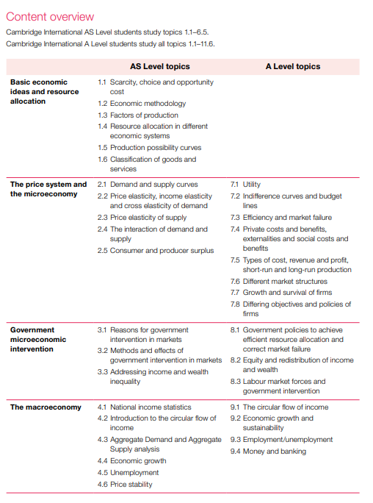
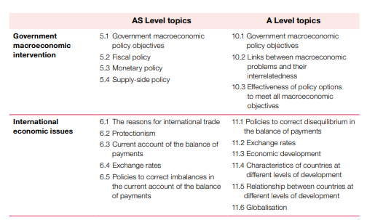

COMPLETE:  The following Massolit course:  MASSOLIT - Micro – Supply and Demand: Demand | Video lecture by Dr Patrick Gaule, Bristol University | READ:  Rupal Patel: Why can’t we just print more money?  Tim Harford: The Undercover  Economist  Freakonomics: A Rogue Economist Explores the  Hidden Side of Everything  Levitt, Steven D., Dubner | WATCH:    Mr Clifford: basic economic concepts  It’s a Wonderful Life  TED - What causes a recession  The Prisoners Dilemma  Ten Principles of Economics, 10th Anniversary Edition  After watching each talk, summarise it in 50-100 words.
EMAIL:  Sana.ahmad@cayprep.edu.ky with your completed work by September 1st with completed documents. If you have any questions, or are struggling feel free to ask for help.  For further research on any topic you can visit:  www.tutor2u.net/economics or https://www.economicsobservatory.com/ | FOLLOW:  Instagram:  @insiderbusiness  @Simplepolitics  @Businessweek @Bloombergbusiness @cnnbusiness @businessinsiderintelligence | FOLLOW:  YouTube:  EconplusDal  Tutor2u  JacobAClifford  Marginal Revolution University  Wall Street Journal  The Economist  The Guardian  The Financial Times  TED & TED-Ed  Khan Academy
Answer the questions and prepare to have them ready for your first economics lesson. If you have any concerns email and of the economics teachers:
Luke.McGahren@cayprep.edu.ky
Michael.Firth@cayprep.edu.ky
Sana.ahmad@cayprep.edu.ky

