**Biology**

|  |
| --- |
| **Key skills developed in this work:**   * Locating, selecting, organising and presenting information from a variety of sources * Translating information from one form to another * Manipulating numerical and other data * Using information to identify patterns, report trends and draw conclusions * Giving reasoned explanations for phenomena, patterns and relationships |

|  |
| --- |
| **Research work:**  <https://www.futurelearn.com/subjects/science-engineering-and-maths-courses/biology-and-biotechnology> |

|  |
| --- |
| **Website links:**  <https://www.cambridgeinternational.org/programmes-and-qualifications/cambridge-international-as-and-a-level-biology-9700/>  <https://www.senecalearning.com/>  <https://www.thestudentroom.co.uk/a-level/>  <https://www.s-cool.co.uk/a-level/biology> |

|  |
| --- |
| **Appropriate additional reading:**   * The Selfish Gene by Richard Dawkins * Silent Spring by Rachel Carson * I Contain Multitudes by Ed Yong * Nature.com * Newscientist.com * Scientificamerican.com |

**Work through the tasks on the following pages**

**Tasks to complete:**

**A: Examination Questions**

#### Units of measurement

1. Complete the diagram below to show: names of the units of measurement, unit symbols, and mathematical operations for converting between units.

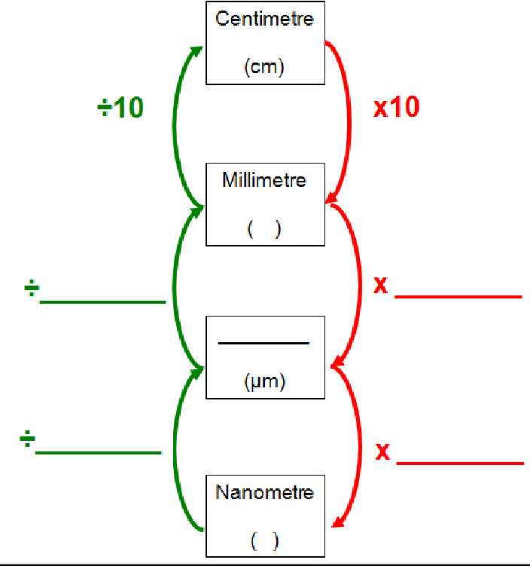

1. Complete the table below to show the corresponding values in nanometres, micrometres and millimetres for the measurements given in each row.

The first row has been completed for you. Add in the correct unit symbols for each answer you give.

|  |  |  |
| --- | --- | --- |
| **Nanometre** | **Micrometre** | **Millimetre** |
| 5 | 0.005 | 0.000005 |
| 1 |  |  |
|  | 1 |  |
|  |  | 1 |
|  | 3 |  |
| 7 |  |  |
|  |  | 0.5 |

#### Magnification and Resolution

1. Define the following terms:

|  |  |
| --- | --- |
| **Term** | **Definition** |
| Magnification |  |
| Resolution |  |

1. Visible light has a wavelength of 400-700 nm. Calculate the best resolution achievable with a light microscope? Show your working out:
2. Watch this video first: [Bing Videos](https://www.bing.com/videos/riverview/relatedvideo?q=how%20to%20calculate%20magnification%20gce%20a%20level%20biology&mid=0734DC61EBCEE53BF7710734DC61EBCEE53BF771&ajaxhist=0). The diagram below shows the general structure of a plant cell when viewed under an electron microscope.

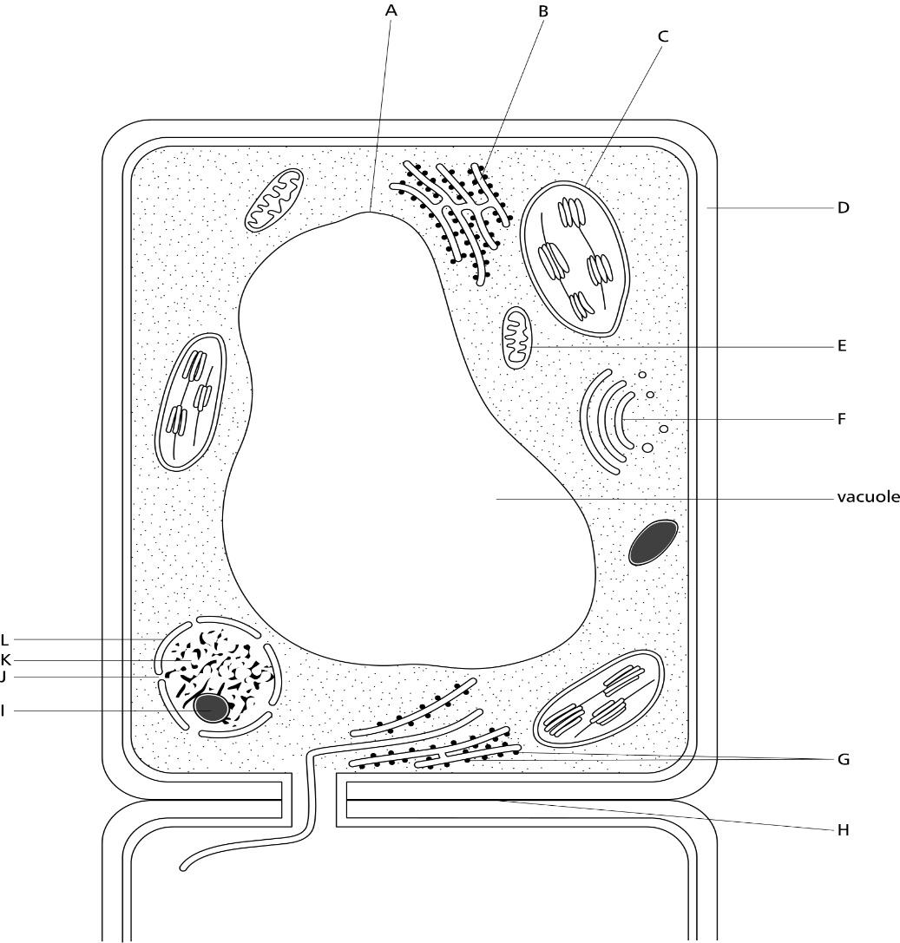

* 1. Calculate the magnification factor of the diagram:
  2. Calculate the thickness of the cellulose cell wall:
  3. Calculate the length of the cell:

#### 40m

* 1. Calculate the length of structure C:
  2. Calculate the length of the vacuole:

#### Cell structure

1. Describe three structures / organelles that are present in generalised plant cells but absent from animal cells.

A)

B)

C)

1. Name the structures in the diagram below

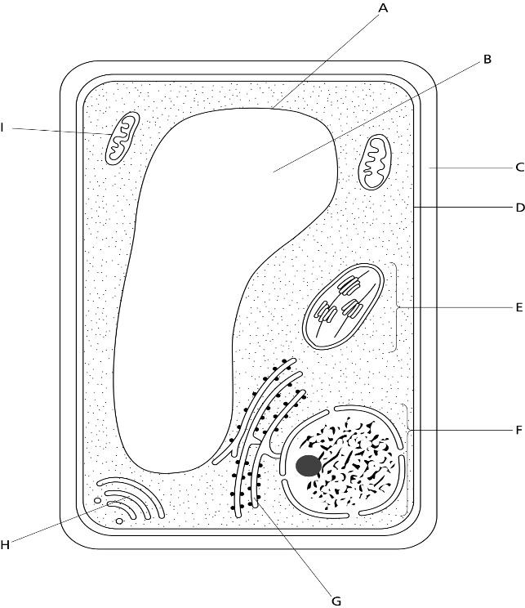

|  |  |
| --- | --- |
| **Letter** | **Structure** |
| A |  |
| B |  |
| C |  |
| D |  |
| E |  |
| F |  |
| G |  |
| H |  |
| I |  |

1. The diagram below shows an electron micrograph of a cell. Name the structures in the diagram.

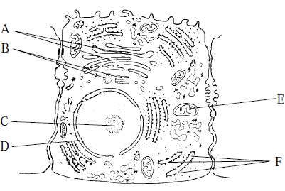

|  |  |
| --- | --- |
| **Letter** | **Structure** |
| A |  |
| B |  |
| C |  |
| D |  |
| E |  |
| F |  |

1. The diagram is a line drawing of a cell as seen with an electron microscope.

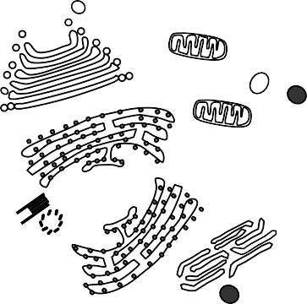

A

B

C

20 μm

D

E

H

F

G

* 1. Complete the table by matching the label to the function and then naming the appropriate part. The first one has been completed for you.

|  |  |  |
| --- | --- | --- |
| **Function of Structure** | **Label** | **Name of Part of the Cell** |
| Controls the activity of the cell. | A | Nucleus |
| Protein/polypeptides are made here. |  |  |
| Aerobic respiration takes place here. |  |  |
| Produces secretary vesicles. |  |  |
| Controls the entry of substances into the cell. |  |  |
| Contains hydrolytic enzymes. |  |  |
| Makes lipids, including steroids. |  |  |

1. With reference to the diagram; is the cell that of an animal or a plant? Give a reason for your answer.

#### Parts of the cell working together

* + 1. Complete the paragraph below to describe how organelles in a cell work together to produce and secrete proteins such as hormones

The nucleus carries all the necessary instructions for the cell to function. The code for protein synthesis is carried in the which are made of

or histones. The instructions are or copied into mRNA (messenger ribonucleic acid). The mRNA then leaves the nucleus via the _ and travels to the _ where the message is read and translated into protein. The newly manufactured proteins are transported to forming face of Golgi body/apparatus in transport . Within the Golgi apparatus the proteins are processed. Vesicles are budded off from the maturing face of Golgi and are transferred to the

for secretion. Glandular cells (e.g. pancreas) contain large amounts of (this is encrusted with ribosomes and is where protein synthesis takes place) and Golgi body. These cells also contain many mitochondria since protein synthesis requires a lot of .

* + 1. The diagram below illustrates cellular secretion. Secretion may be continuous or it may be intermittent, only occurring to coincide with some other activity outside the cell.

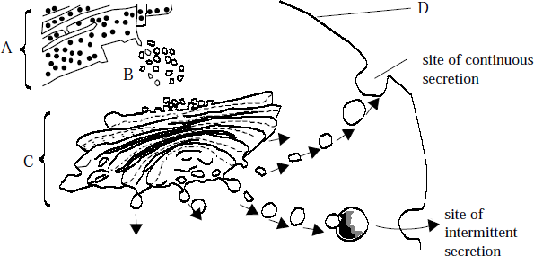

1. Name A, B, C and D.
2. State the function of structure B.
3. Describe the role of structure C in secretion.

#### Prokaryotes and Eukaryotes

1. 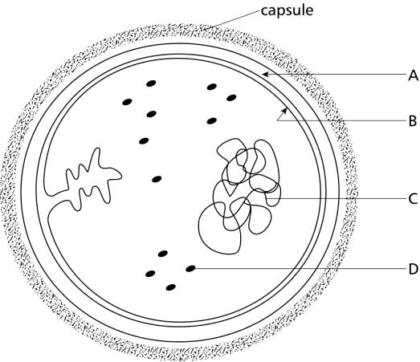The diagram below shows *Staphylococcus,* which is a prokaryotic cell*.* Label parts A to D
2. The following table compares some features of a prokaryotic and eukaryotic animal cell. Complete the table on the next page by using ‘present’, ‘absent’ or a short descriptive phrase. The first has been completed for you.

|  |  |  |
| --- | --- | --- |
| **Cellular Feature** | **Prokaryotic Cell** | **Eukaryotic Animal Cell** |
| Cell wall | Present | Absent |
| Cell surface membrane |  |  |
| Nucleus |  |  |
| Membrane bound organelles |  |  |
| DNA |  |  |
| Plasmids in the cytoplasm |  |  |

**B: Biology Research Tasks** Complete **all 3** of the tasks below.

**Task 1: Protein structure**

1. Find and draw a generalised structure of an amino acid.
2. Give a general **comparative** description of the primary, secondary and tertiary structure of a protein. [Include terms such as:- polypeptide chains; alpha helices; beta pleated sheets; hydrogen bonds; ionic bonds; disulphide bonds; hydrophobic R-groups; Hydrophilic R-groups; prosthetic groups; conjugated proteins]
3. Draw the ring structure for α and β glucose. Learn these structures and list the differences between the two.

**Task 2: Biological Molecules**

The three main groups of biological molecules are: proteins, carbohydrates and lipids. For each group, find out where these molecules are found in a standard animal cell and what their role in that structure is.

**Task 3: Biology Practical**

Find out what the Benedict’s test is used for, give an outline of the experimental method and state the difference between a reducing and non-reducing sugar.

|  |
| --- |
| **Other:**  <https://www.labiotech.eu/tops/diy-biology-experiments-home/> |